ENH 286 -
Merial
Honeywell 99EXhc Mobile Computer Training

Author: Letitia Sims
Creation Date: June 23, 2014
Last Updated: June 23, 2014
Document Ref: Merial_5174
Version: 1.0

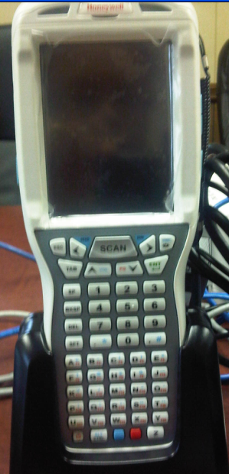

Table of Contents
A. Keyboard 4
B. Battery 8
C. Sign into Scanner (Mobile Computer) 10
D. Creating Labels: 12
E. Planting Process 18
F. Harvest Process 24
G. Exception process for vHVT virus 36
H. Maintenance Reason Codes: 44
I. Edit Control Report 54
J. Requesting AI Control Report from Oracle Form: 59
K. End of Process 63

Keyboard

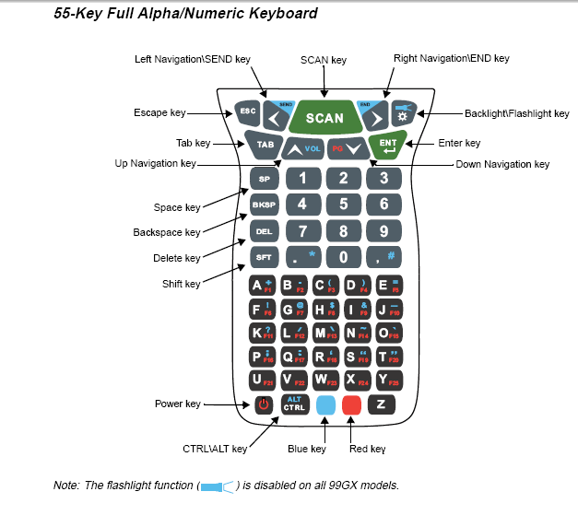

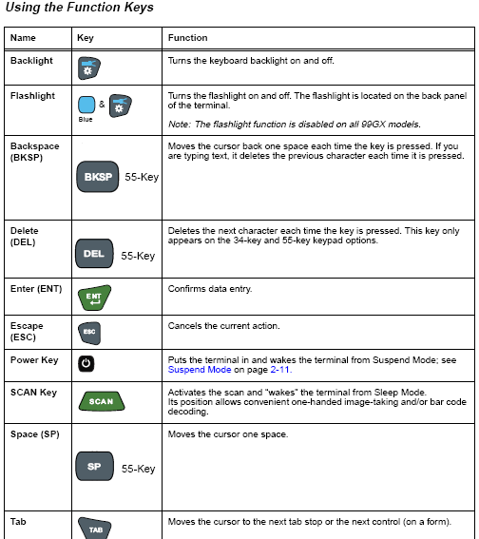

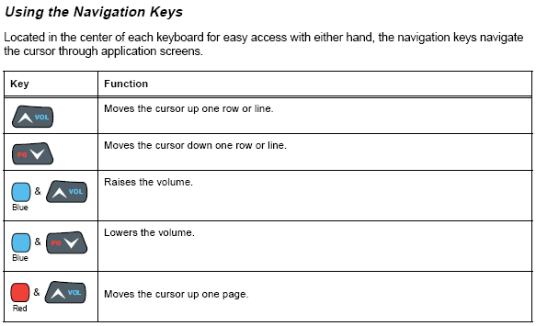
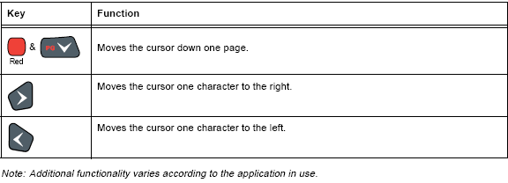

Additional function keys:

+ exit current screen

+ return to previous screen

+ list of values

+  soft reset (warm boot)

:
- turns on device
- puts the device in “suspend” mode (i.e. sleep)

Battery

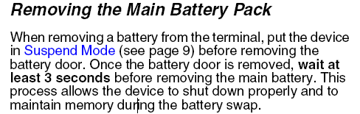

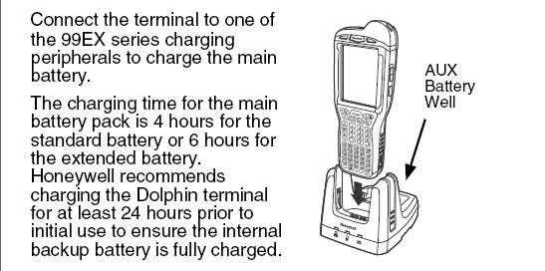

Timeout settings:
IMPORTANT --
Each mobile device is set to 60 minutes of connectivity to the network. So long as the user continues to use the device under 60 minutes, the data entered will not be lost. All data ‘submitted’ will be captured. The device will go into a “sleep” mode, meaning the screen will go black, but this does not mean that the connectivity is lost.

After 60 minutes, the user will have to sign back into the device with the Oracle userid and password; however, any data that was not ‘submitted’ will be lost and the user will have to re-enter the data.

Sign into Scanner (Mobile Computer)

- User clicks
- (Note: if the Naurtech screen screen returns, click on “Session” → “Connect”

- User clicks or chooses ‘1’ for Default

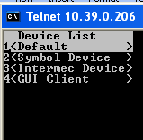

- Enter your Oracle user name and password (you must have an Oracle userid and password in order to access this program)

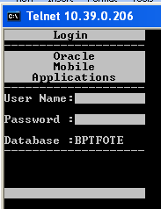

- Password will be show on the screen as asterisks

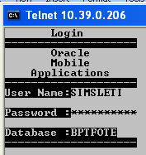

- The main menu will appear:

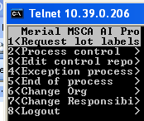

Creating Labels:

Creating Rack Code Labels:

- Users will be provided with a Microsoft Excel Marcos label utility that will provide the ability to create Rack Code labels.
- Enter the Rack Code and the number of that label desired

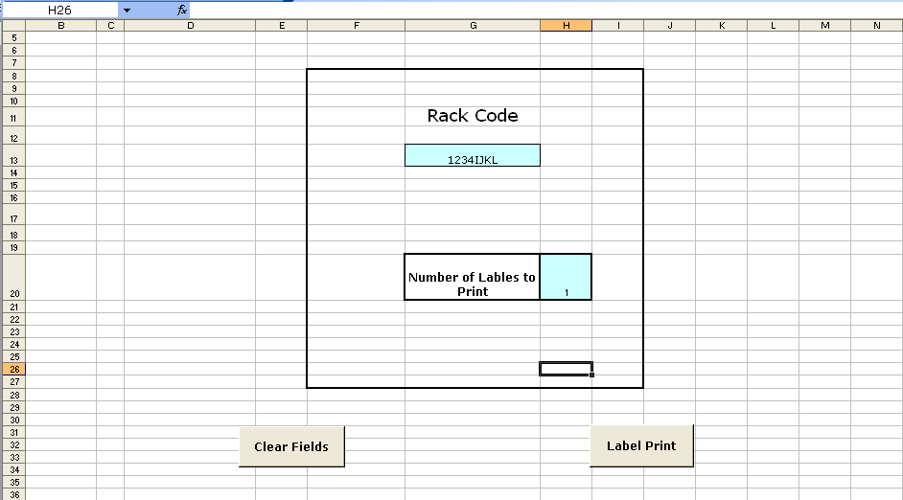

- Press 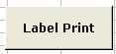

  - The screen will automatically go to “Sheet 2” and ask the user if they want to “save the changes made on the label.csv?”
  - The user must choose either ‘Yes’ or ‘No’. If you choose cancel, you will receive a debug error message and your labels will not print.

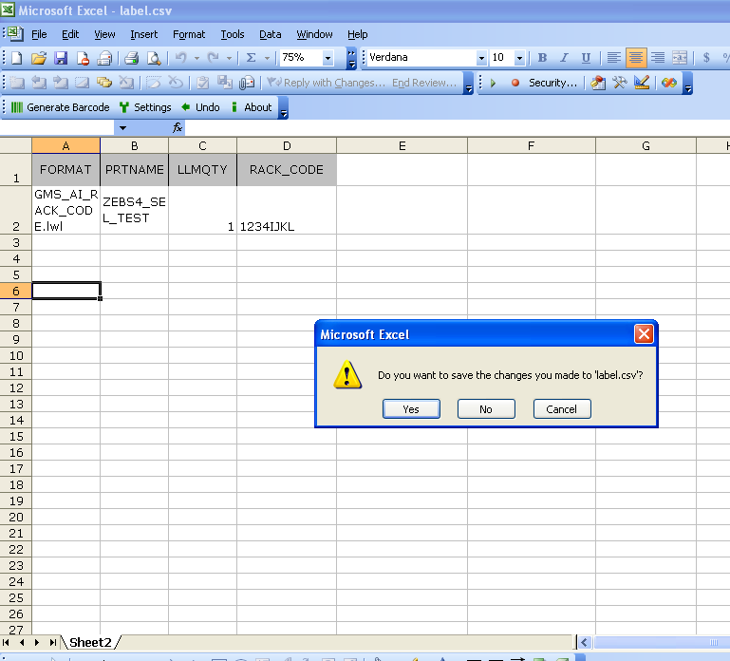

- The Rack Code labels will be printed from the Zebra S4M label printer.

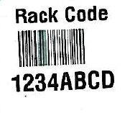
- These are permanent labels used to mark the racks once, unless otherwise repeated.

Creating Ser Code (Lot) Labels:

When starting a process for a cell start, the user must first create Ser Code (lot) barcode labels.

- Choose Request lot labels and the Print Unique Labels screen will return

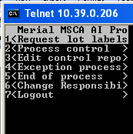

- User will choose the org (organization) code
- Enter GMS (if requested)

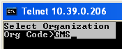

Each rack used in the process of this cell start will be associated with the Plant Number and Ser Code (lot) label based on the number of racks planted.

- User will know the cell start (lot number) and the number of racks they will need for the process.
- (Note: Lot number must be in capital letters. Use soft keyboard with stylus and set it to CAPS. Then close the soft keyboard).

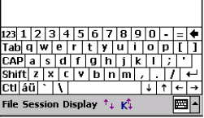

- The racks will have permanent barcode labels on them and will be known as the “Rack Code” label
- User will manually enter the cell start Lot Number, Plant Number and number of labels (which will equal to the approximate number of racks to be planted)

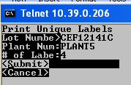

- User presses the button to highlight “Submit” and screen returns to main menu

- If user enters wrong information, user can arrow down to choose to “Cancel” and exit the screen to start over.

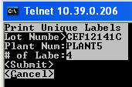

- User has to enter a lot number that is for a Cell Start item or the error message should be “No Result is found”

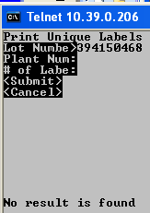

- Once submitted, the Ser Code (lot) labels are printed on the Zebra S4M label printer
- (Note: the barcode is a unique identifier that represents the lot number and the plant number to allow both to be captured with one scan):

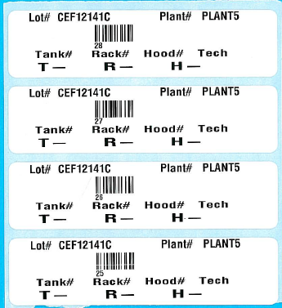

When there is more than one item number with the same cell start lot number:

If there is a lot number that is used by two item numbers, you will be prompted to choose which item you want:

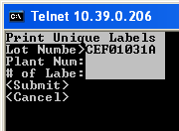

- The following screen will return

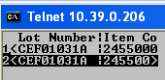

- Use your right arrow cursor to scroll to the right in order to see the full item number

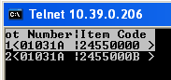

- Choose the desired item with the up or down cursor or the number choice and press

Planting Process

Bottles are filled and placed on the roller racks. This next section is how the scanner will be used during the vaccine planting process.

Process Control → Process AI (screen)

The process control screen associates the cell start lot number, plant number, virus, and process to an available rack(s) by entering the rack and scanning the Ser label (lot) barcode’s unique number. This is done during the planting process. It also establishes the control number for reconciling remaining processes to the number of racks planted.

- User chooses Process control screen from main menu

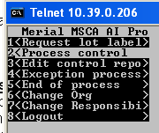→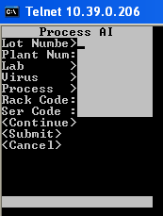

- User manually enters the Lot Number and Plant Number

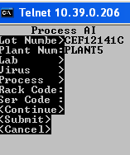

- User clicks and chooses the Lab from the list of values

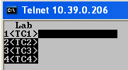 →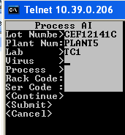

- User clicks and chooses the Virus from the list of values

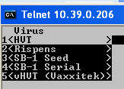→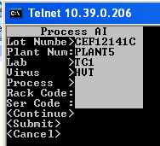

- If HVT, Rispens, SB-1 Seed or SB-1 Serial is chosen, the system will default to “Plant & Infect” for the first process

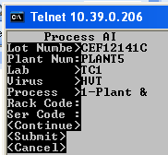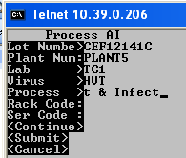

- If vHVT (Vaxxitek) is chosen, the system will default to “Plant” for the first process

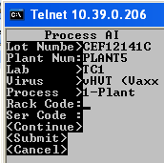

- User clicks  to scan the Rack Code Label

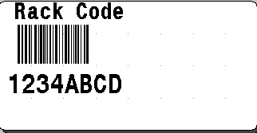

- Remaining Rack Codes used in this example are:
- 1234EFGH
- 1234IJKL
- 1234MNOP

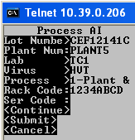

- User click to scan the Ser Code (lot) label (note: the unique number under the barcode will appear on the screen after the scan):

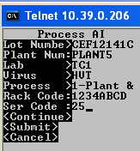

- Label scanned was:

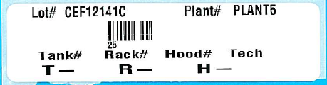

Note: If user scans a Rack Code that is already associated with a different Ser Code (lot) label (other than what is currently being used), the error message should return as “Label for another lot”. Refer to business process rules and appropriate notifications.

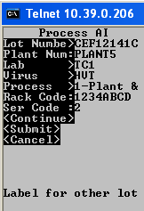

- When ready, the user can continue to associate the racks used with this lot:

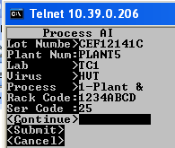→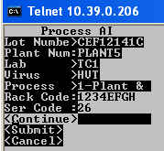→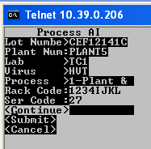

- Note: If a Ser Code (lot) label has already been associated with another rack, the error message returns as “Rack already assoc”
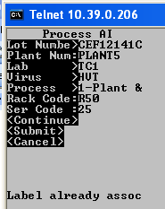

- When all desired racks have been entered for association with the Ser Code and Rack Code, the user can arrow down to choose “Submit”

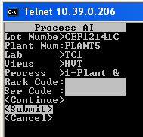

- The screen will return to the main menu

Harvest Process

The same Process AI screen will be used for the all of the remaining processes for the virus chosen.
  - For the HVT, Rispens, SB-1 Seed and SB-1 Serial viruses, the only other process that is available after “Plant & Infect” is “Harvest”. However, “Harvest” will not be available in the list of processes if the “Plant & Infect” process has not been completed first.
  - For the vHVT (Vaxxitek) virus, the first process available will be “Plant”. Once the “Plant” process has been completed, the next process will be available in the process list. This is “Infect Seed”, followed by “Harvest Seed”, “Infect Serial” and “Harvest Serial”. If the proceeding process has not been completed, the user will not be able to choose the next expected process for this virus.

- HVT, Rispens, SB-1 Seed and SB-1 Serial process:

Below represents the example of the Harvest process for the HVT virus which is the same process for Rispens, SB-1 Seed and SB-1 Serial viruses:

- The user will manually enter the lot number and plant number
- The user will choose the lab and virus

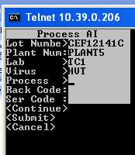

- The user would choose the “Harvest” process from the list of processes:

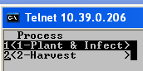

- The user scans the desired Rack Code and Ser Code
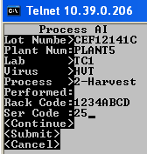

- The user presses to highlight Continue

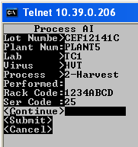

- The screen will return with the number of racks harvested versus the total number of racks eligible for the Harvest process for this particular Cell Start Lot and Plant numbers

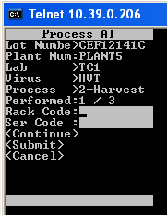

- The user will enter the next Rack Code and Ser Code for the Harvest process
- The user will continue to enter all Rack Codes and Ser Codes until all desired racks have been entered for the Harvest process
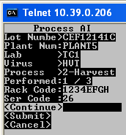

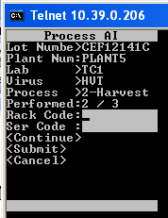

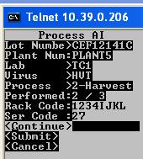

- Once all racks have been entered for the Harvest process, the “Performed” count will be equaled.

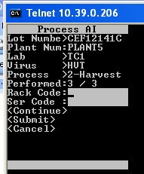

- Use Page Down button and highlight “Submit”

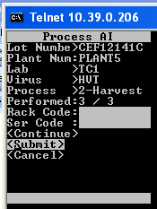

- Note: The “Performed” section on the screen lets the user know how many racks have been harvested compared to the number of racks that have been planted & infected.

- The screen will return to the main menu

- vHVT (Vaxxitek) Process

Below represents the example of the processes for the vHVT (Vaxxitek) virus.

- User will create the number of lot labels based on how many racks planted for vHVT process

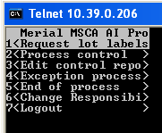 →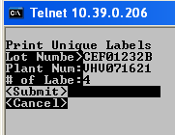

- The screen will return to the main menu
- The labels will look like the following:

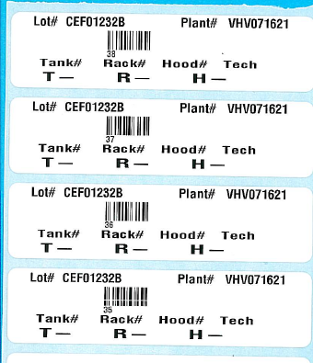

- After lot labels are printed, the user enters the Process control form:

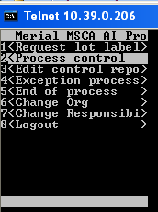

- User associates all racks through the “Plant” process for the vHVT virus
- User will manually enter the cell start Lot number and plant number
- User presses and chooses the lab they are currently working in
- User presses and chooses the vHVT virus

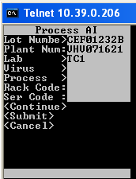→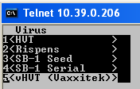→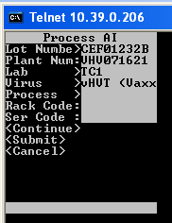

- User presses and the process will auto-populate with the “Plant”:

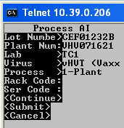

- User scans the Rack Code and Ser Code (lot) label

- User presses to highlight “Continue” after each Rack and Ser Code is entered

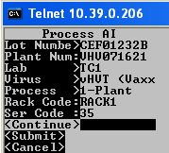→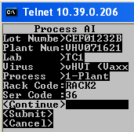→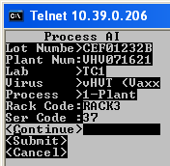

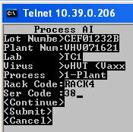

- User presses to highlight “Submit”

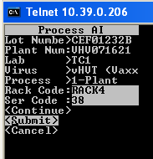

- All racks have now been associated with the Ser Code (lot) label under the “Plant” process.
- The screen will return to the main menu

- When user is ready to record the “Infect Seed” process for some of the racks, the user will go back into the Process control screen:
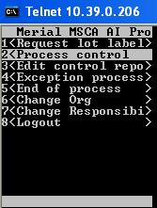

- User enter lot number, plant number, lab, and vHVT virus:

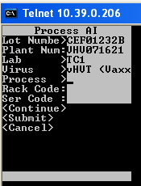

- User presses to choose the process

- Now that the racks are eligible for the next process, the user will now see the “Infect Seed” as a process option.

- Note: The “Plant” process is still an available option because more racks can be added if needed.

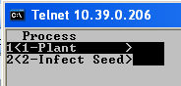

- Note: User determines the Rack Codes to perform the “Infect Seed” process against. For this example, it will be for RACK1 and RACK2:

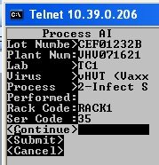 → 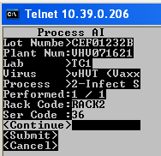

- User presses and chooses “Submit” indicating that the “Infect Seed” process has been completed for these racks

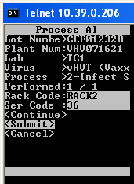

- The screen will return to the main menu
- These racks have now been recorded in the system showing the “Infect Seed” process has been completed
- When user is ready to record the “Harvest Seed” process for the racks used in the “Infect Seed” process, the user will go back into the Process control screen:

- User enter lot number, plant number, lab, and vHVT virus:

- User presses to choose the process

- Now that the racks are eligible for the next process, the user will now see the “Harvest Seed” as a process option.

- Note: The “Plant” and “Infect Seed” processes are still available options because more racks can be added if needed.

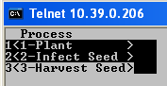

- User will enter the same racks for the “Harvest Seed” process. For this example, it will be for RACK1 and RACK2

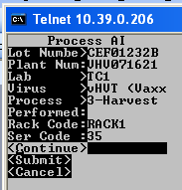 → 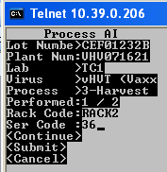

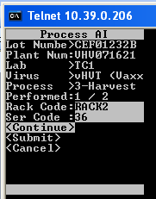 → 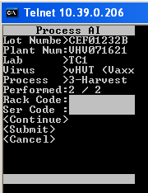

- Note: Notice that the system remembers that there are only two racks eligible for the “Harvest Seed” process even though there are a total of four racks associated with this lot number in this example. (See the Performed section of the screen)

- User presses and chooses “Submit” indicating that the “Harvest Seed” process has been completed for these racks

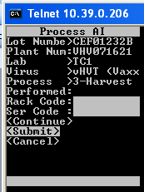

- The screen will return to the main menu
- These racks have now been recorded in the system showing the “Harvest Seed” process has been completed
- When the user is ready, the Exception process can be used to disassociate the racks used during the “Harvest Seed” process

Exception process for vHVT virus
To remove “Harvest Seed” processed racks:

- User will enter into the Exception process screen

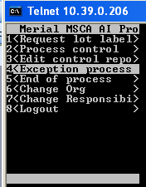

- User will manually enter the lot number and plant number
- User will scan the Rack Code and Ser (lot) Code

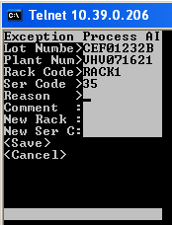

- User presses and a list of reason codes returns

- User chooses “Harvest Seed”

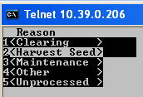

- User can choose to place a comment if desired, but is not mandatory

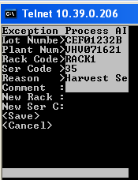

- User presses to highlight “Save” 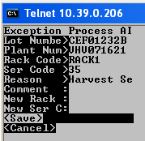

- The main menu returns
- User repeats the same exception process for the remaining “Harvest Seed” racks

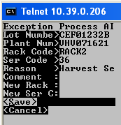

- The main menu will return
- The “Harvest Seed” racks have now been disassociated.

- When user is ready to record the “Infect Serial” process for remaining racks, the user will go back into the Process control screen:

- User enter lot number, plant number, lab, and vHVT virus:

- User presses to choose the process

- Now that the racks are eligible for the next process, the user will now see the “Infect Serial” as a process option.

- Note: The “Plant”, “Infect Seed”, “Harvest Seed” processes are still available options because more racks can be added if needed.

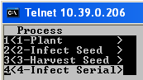

- The remaining racks will be used from this point forward. For this example, it will be for RACK3 and RACK4

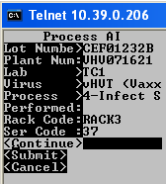 →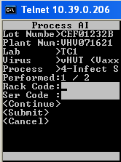 → 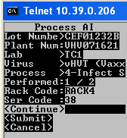

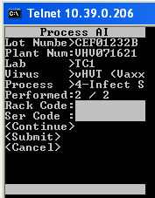

- User presses to highlight “Submit”

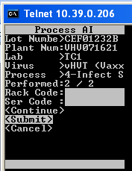

- The main menu will return
- Note: Notice that there are only 2 out of 2 racks recognized for the “Infect Serial” process. This is because the previous racks used in the “Harvest Seed” process are no longer recognized because they have been disassociated through the Exception process.

- When user is ready to record the “Harvest Serial” process for remaining racks, the user will go back into the Process control screen:

- User enter lot number, plant number, lab, and vHVT virus:

- User presses to choose the process

- Now that the racks are eligible for the next process, the user will now see the “Harvest Serial” as a process option.

- Note: The “Plant”, “Infect Seed”, “Harvest Seed”, and “Infect Serial” processes are still available options because more racks can be added if needed.

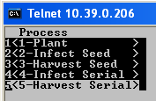

- The same racks used to complete the “Infect Serial” process will also be used in the “Harvest Serial” process. Again, for this example it will be for RACK3 and RACK4

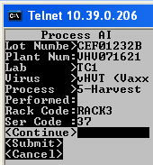 → 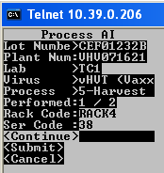 → 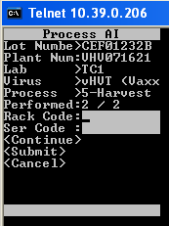

- User presses to highlight “Submit”

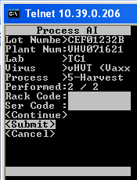

- The main menu will return

- Exception Process:

The Exception Process is used when the technician has to remove the association between a rack, lot and plant number due to rack malfunction, contamination, Harvest Seed racks or other corrections prior to the end of the process. The technician can also provide the reason and any comments to assist in the explanation of the exception.

There are five reason codes that can be used during the exception process. However the “Harvest Seed” reason code will be available as an option only if the rack(s) entered have been recorded in the system as completed through the “Harvest Seed” process for the vHVT virus. Please see: Exception process for vHVT virus (removing “Harvest Seed” processed racks).

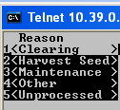
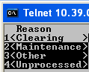
Versus

Important to remember:
Per the reason code chosen, the counts can be affected in different ways.
- “Clearing” will clear the prior process
- “Other” clears the racks in the count including the planted racks.
- “Unprocessed” will un-processes the chosen process.
- “Maintenance” will replace the rack with another. The data associated with the malfunctioning rack will be transferred to the replacement rack.

The Exception Process must be done before the Harvest process for all viruses except for the Harvest Seed process for the vHVT virus and the Unprocessed reason code; as the Harvest process is eligible for ‘un-processing’.

A new Ser Code (lot) label does not have to be created if the original one can still be used.

Maintenance Reason Codes:
- Maintenance Reason Code

A user will choose the ‘Maintenance’ reason code if the rack is not longer working properly and another rack will be used in its place. This reason code is used only if the user is going to replace the malfunctioning rack with another rack.
- Note: Before starting the exception process, determine if the lot label that is on the malfunctioning rack can be reused. If it cannot (i.e. it gets torn when trying to remove it from the rack or it won’t re-stick securely to the new rack), then create a new lot label through the “Request lot label form”. This new label will not need to be processed through process control form because the history will be transferred to the new label in the Exception process.

- User will choose the Exception process form
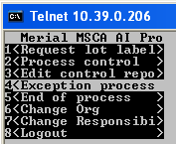

- User enter lot number and plant number
- User will scan the Rack Code and Ser Code
- User presses to choose the reason

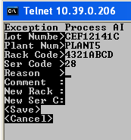

- User chooses “Maintenance”

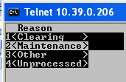

- User can choose to place a comment if desired, but is not mandatory

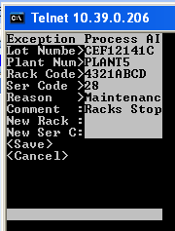

- User scans the Rack Code which is on the replacement rack
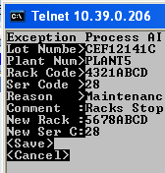

- User presses to highlight “Save”

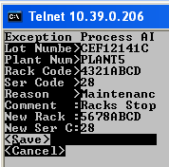

- The main menu will return
- The following AI control report is generated through The “Edit control report” form and it is manually requested. (Please see Edit Control Report section for information on this report)
- Below is the reporting result of this exception

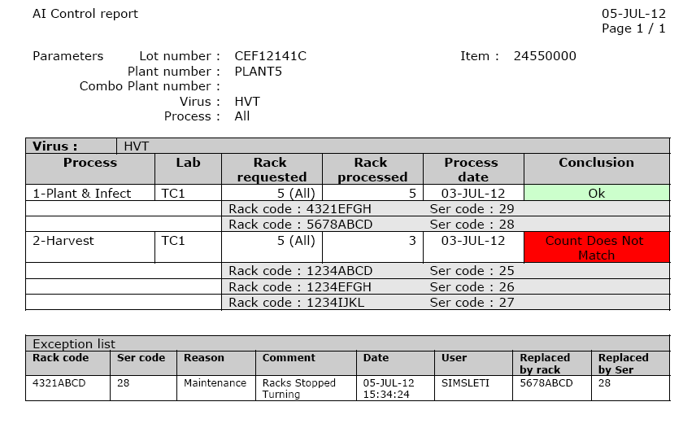

- Clearing Reason Code:
The “Clearing” reason code keeps the rack count in the last process completed; however, the rack will not be available to any remaining processes.

- User will choose the Exception process form
- User enter lot number and plant number
- User will scan the Rack Code and Ser Code
- User presses to choose the reason

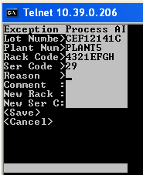

- User chooses “Clearing”

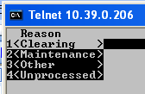

- User can choose to place a comment if desired, but is not mandatory
- User presses to highlight “Save”

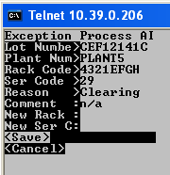

- The main menu returns
- Below is the reporting result of this exception

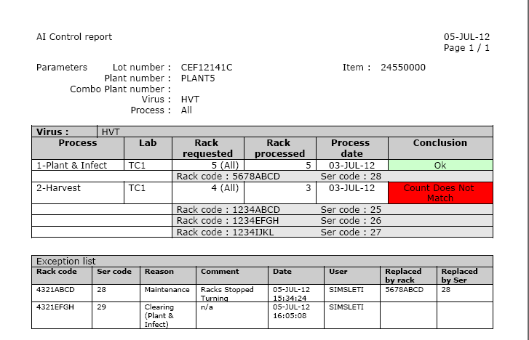

- Other Reason Code:

“Other” reason code will remove a rack(s) from the count as if it never happened.

- User will choose the Exception process form
- User enter lot number and plant number
- User will scan the Rack Code and Ser Code
- User presses to choose the reason

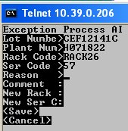

- User chooses “Other”

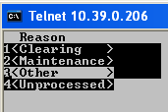

- User can choose to place a comment if desired, but is not mandatory

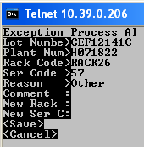

- User presses to highlight “Save”

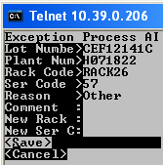

- The main menu returns
- Below is the reporting result of this exception

- Report showing details before using the reason code “other”:

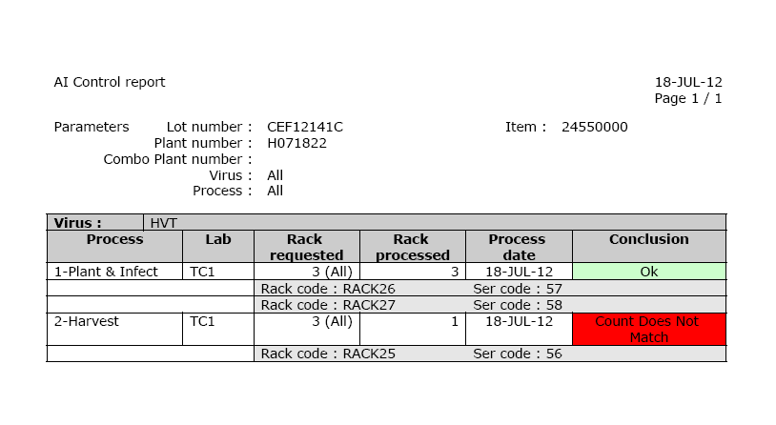

- Report showing details after using reason code “other”:
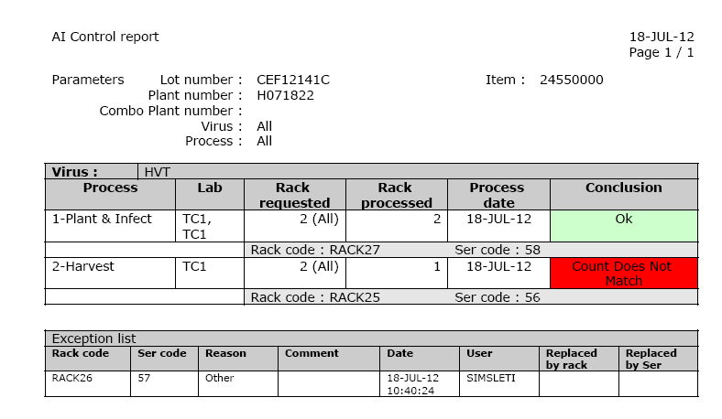
- Unprocessed Reason Code:

The “unprocessed” reason code is used when the user was to remove the rack from the “rack processed” column of the AI Process Report. It does not remove the rack from the “rack requested” column.

- User will choose the Exception process form
- User enter lot number, plant number,
- User will scan the Rack Code and Ser Code
- User presses to choose the reason

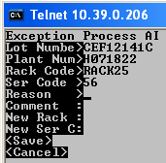

- User chooses “Unprocessed”

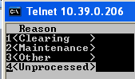 → 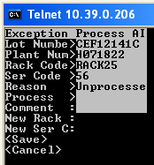

- Choose the process for which the racks will be removed

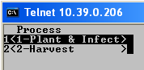 → 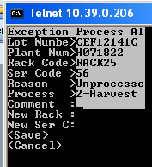

- User can choose to place a comment if desired, but is not mandatory
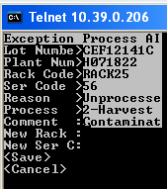

- User presses to highlight “Save"

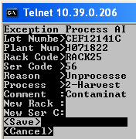

- The main menu returns
- Below is the reporting result of this exception

Before using the “unprocessed” reason code:

- After using the “unprocessed” reason code:

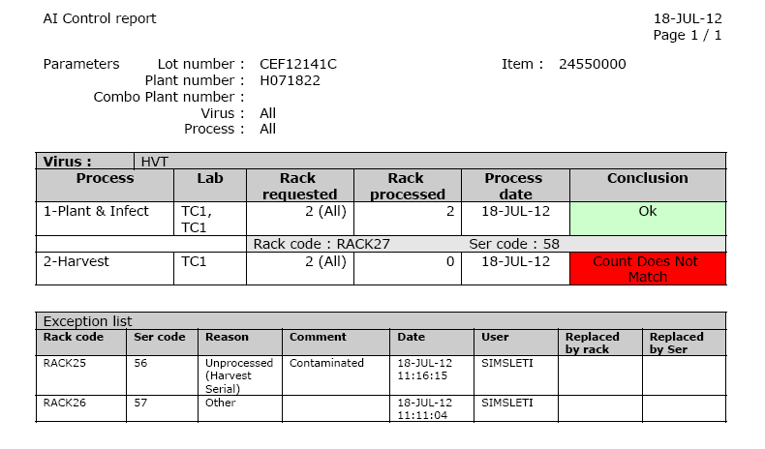

Edit Control Report

Edit control report → Call report (screen)

The Edit Control Report form provides the user with detail information of the events captured in the system associated with the cell start number and plant number. If you leave the virus and the process blank, you will get a separate report for each process completed. If you specify the virus and the plant, you will receive a report specifically for the virus and process requested.

Below are examples of how to create an AI Control Report:

- From the main menu, the user will choose “Edit control report”
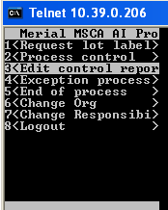

- The user can enter only the lot and plant numbers, leaving other information blank, if desired
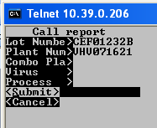

- The following report will return:

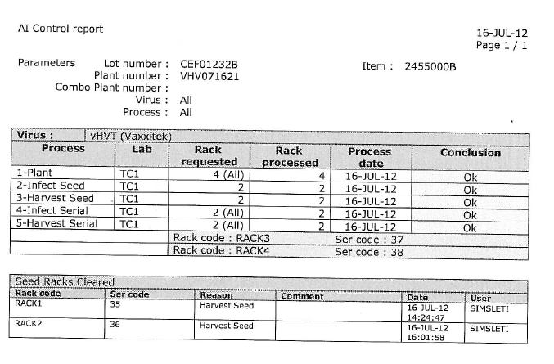
- The user can choose a specific virus

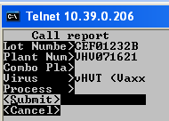

- The following report will return:
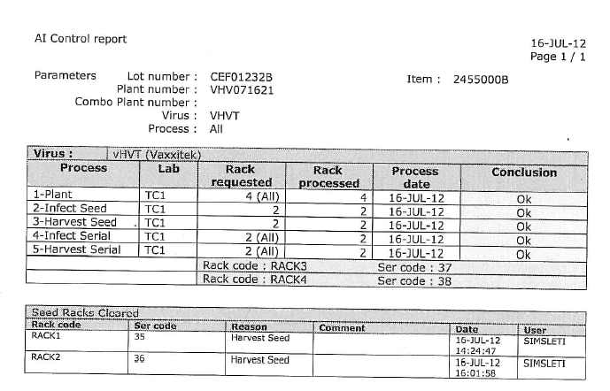

- The user can choose a specific virus and process
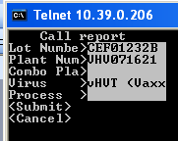→

- User clicks + for the list of process values

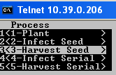 →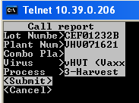

- The following information is printed on the report:

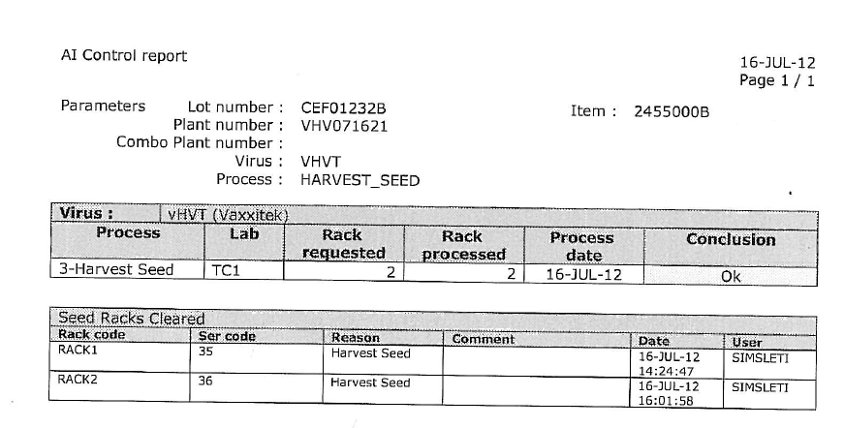

For HVT / Rispens Combination processes, the “Combo Plant” feature can be used when printing a report. For this combination process, the lot number is the same but the Plant numbers will be different for each virus.

- User will enter the lot number and one of the plant numbers used
- User will enter the second plant number next to “Comb Pla(nt number)”

- User presses to highlight Submit

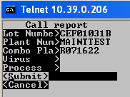

- The will receive two reports per virus
- The following reports will return

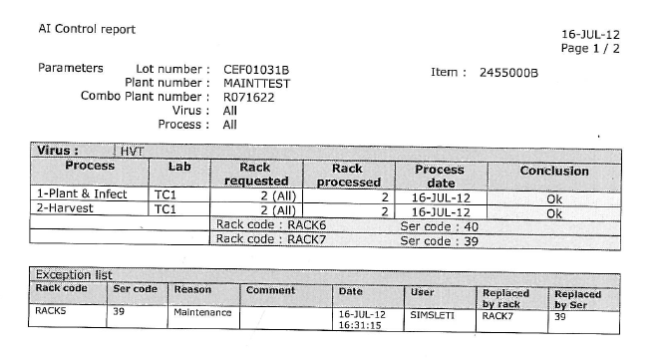

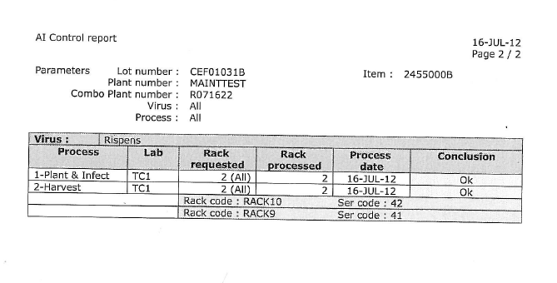

Requesting AI Control Report from Oracle Form:

- Choose the Merial Inventory US Select responsibility
- Click View → Requests

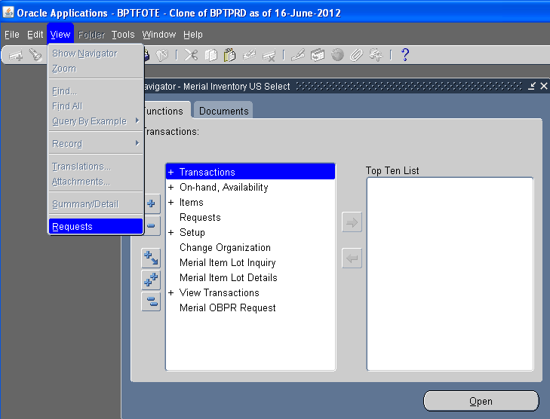

- Click Submit a New Request…

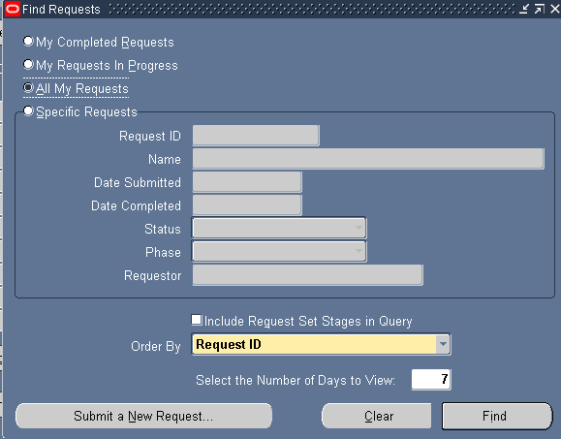

- Run a Single Request (defaulted)
- Click OK

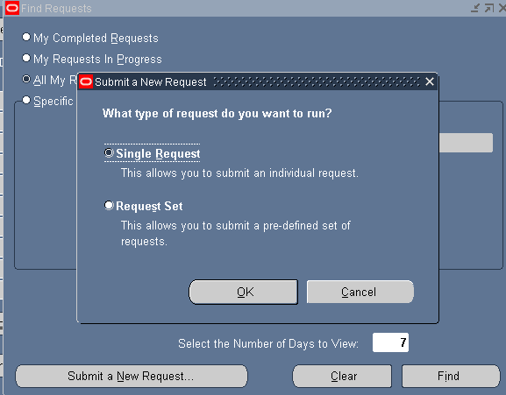

- Click the … button for a list of reports
- Type %AI% and press Find
- Choose ‘Merial Gainesville AI Control Report’

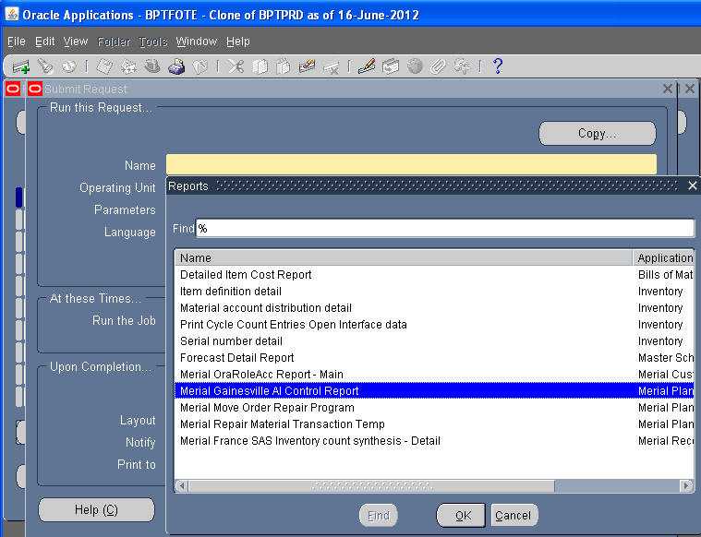

- Press OK
- Enter the Parameters (Note: the Lot Number and Plant Number must be entered)

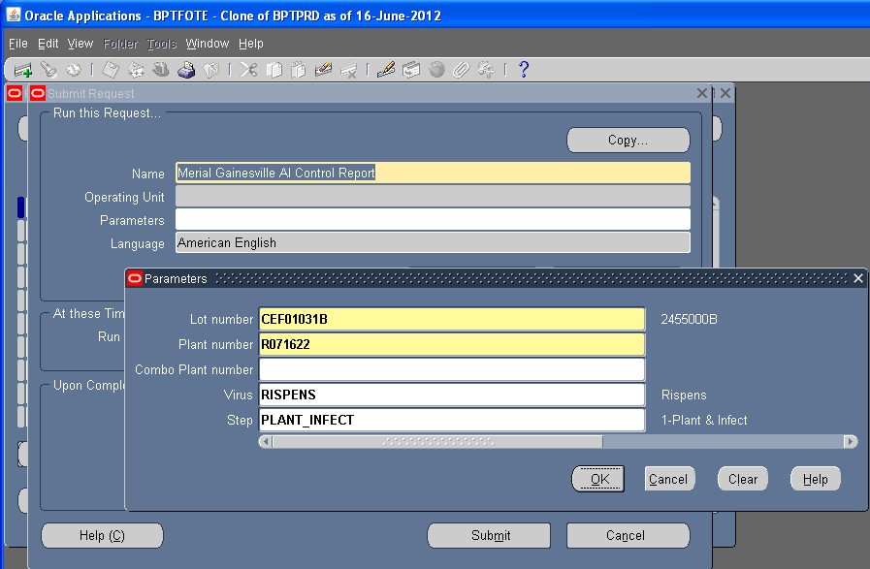

- Click OK

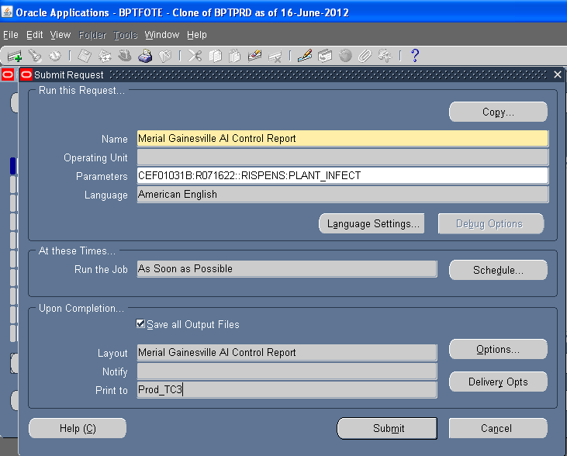

- User can see what printer the report will print to (Prod_TC3 = Lab TC3)
- Click Submit

End of Process

The “End of Process” allows the user to disassociate all racks used in a process so that the racks can be used for future virus processes. It is mandatory to print the AI Control Report prior to completing the “End of Process” in the system.

- From the main menu, the user chooses “End of process”

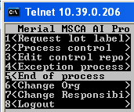

- User enters the lot number, plant number, lab, and virus
- Note: The virus will auto-populate when you press

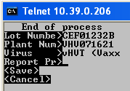

- Note: The user will need to manually print the report from the “Edit Control Report” form prior to entering the “End of Process” form. If the End of Process is done before the report is generated, there is no documentation available for reference afterwards.

- User presses and will be required to answer if the “Report Pr(inted?)” by choosing “Yes” or “No”

- Choose “Yes”

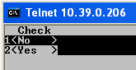

- User presses and Save is highlighted.

- Press again

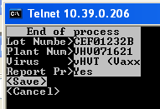

- The main menu returns
- the End of Process will disassociate all racks as expected

Note: If the user chooses “No” when asked if “Report Pr(inted?)”, then the system will not allow the End of Process to continue:

